Dongfeng Kingrun

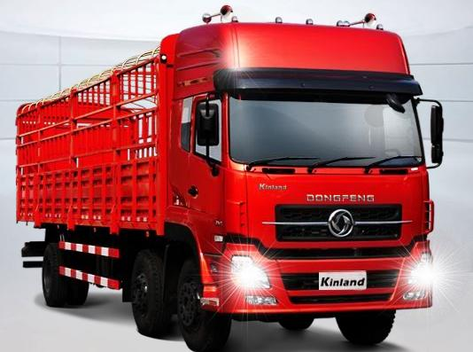

Technology - adopting everyone’s merit to make itself leading

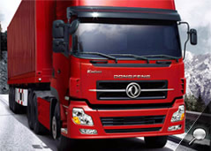
The cab of Dongfeng style is sturdy but elegant.

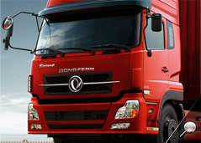
The shape looks doughty and also looks flexible and streamline, which not only shows the rough vigor but also accords with oriental aesthetic viewpoint.

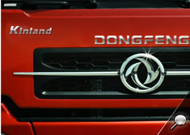

The solid Dongfeng Logo with two swords shows a kinglike air. Drive this vehicle and you will enjoy the sense of success.
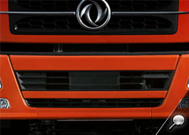
Whole double-layer steel bumper with a beautiful outline exhibits sufficiently Dongfeng’s care for the clients.
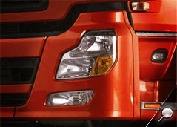
A pair of glowing crystal headlights looking like tiger teeth is just as a finishing touch which adds a kinglike air to the vehicle.

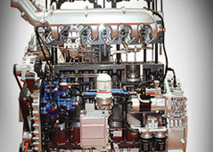
Dongfeng Tianlong has a wide range of power 230-420 horsepower.
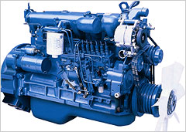
Dongfeng Tianlong has a wide range of power 230-420 horsepower.
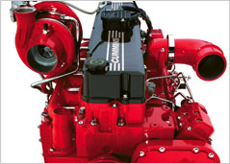
Dongfeng Tianlong has a wide range of power 230-420 horsepower.
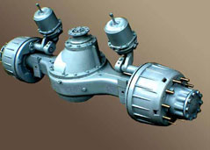
Dongfeng new generation 13-t single and double heavy wheel axle adopts international technology with the quality of “gear-impact resistance, large loading, big twisting moment and long life-span”.

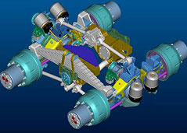
Dongfeng new generation 13-t single and double heavy wheel axle adopts international technology with the quality of “gear-impact resistance, large loading, big twisting moment and long life-span”.

Comfort - upgrading to star-level

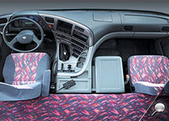
Wraparound instrument desk
The upgraded star-level design ensures Dongfeng Tianlong a movable home for the driver and passenger. The wraparound instrument desk is arranged with the driver as center, so he can reach conveniently the switches and buttons.

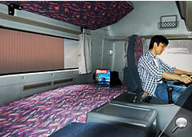
Wraparound instrument desk
The upgraded star-level design ensures Dongfeng Tianlong a movable home for the driver and...
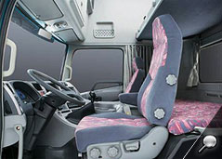
Super-large room
After an exhausted long-distance drive, a cab with large room is a best choice for the driver. The 800mm wide cozy berth which is widest in heavy-duty truck in China will comfort you directly.
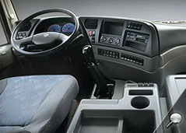
Super-large room
After an exhausted long-distance drive, a cab with large room is a best choice for the driver. The...

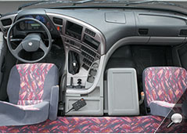
Quiet design inside vehicle (68db)
The noise in the high-technological quiet design vehicle (68db) is lower than what State Standard requires, which embodies our care for the client. At the same time, some practical and convenient establishments such as cooling/heating box, fluorescent lighting, automatic skylight and many applicable storage cases are furnished in Dongfeng Tianlong and Hercules, which show Dongfeng’s humane thoughts everywhere.

The cab types Standard Lengthened High-topped
S L H
Basic type Comfortable type Luxury type
1 2 3

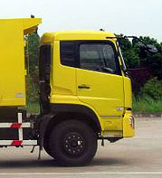
Standard cab:
mainly used for special-purpose vehicles and engineering vehicles
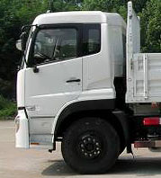
Lengthened cab:
mainly used for tractors and road vehicles
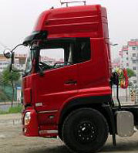
High-topped cab:
mainly used for tractors and road vehicles

Economy - with comprehensive upgrading, it is better than others in the aspect of economy.
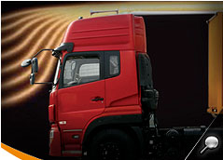
The advanced low-drag design will reduce the power loss due to wind.

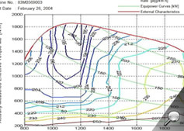
The Leading engine technology saves more oil for you. With minimum dCi11 of 190g/kW.h, this technology has set the lowest oil consumption record. Optimized chassis system makes the complete vehicle oil consumption 5~18% lower than that of other same-level vehicles.

