Dongfeng Kingrun

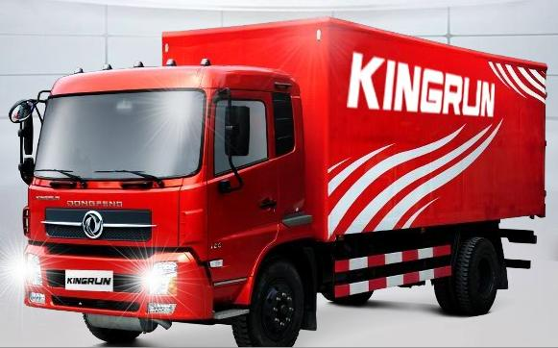

Color:
Peal molybde num red; Benz blue; Jade white

Comfort and convenience
Wide, comfortable and human driving conditions
Adjustable steering wheel, accessible switch and electrical instruments in the real sense:

The height of the steering wheel post can be freely adjusted and so can the front and back angles; with optimized man-machine engineering wraparound instruments closely deployed, it is very tidy and various buttons and switches are easy to reach; adopting many real electronic instruments such as stepper motor, microcontroller, light emitting diode and CAN bus, the anti-reflective liquid crystal display shows related information which is clear and easy to read; the cruise control switch is available.

Wraparound instrument disposal, adjustable steering wheel
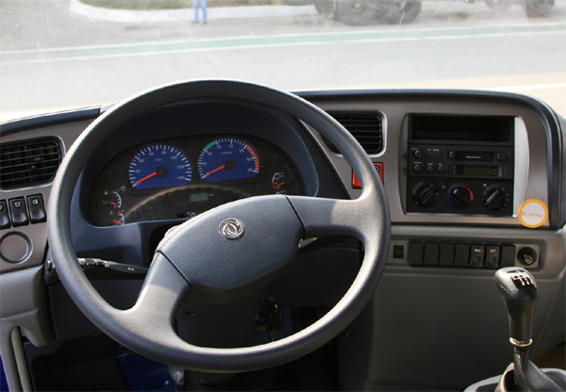

Cruise button (optional)
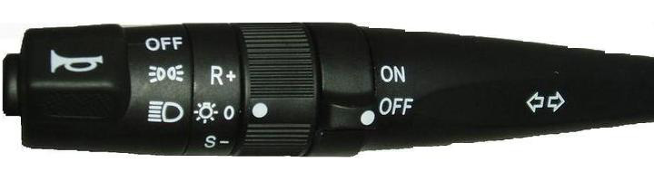
Fault code display, fault choice knob
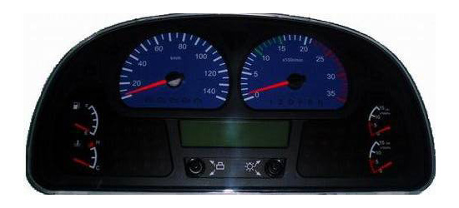
Comfortable seat, wide front room
By the human engineering design, the seat may be adjusted according to everyone’s sitting position. With the widest scope to adjust in the same type of products, it gives the driver comfort. Co-driver position is also spacious. In the luxury type, you can also choose to mount an airbag seat.

Store case with large room, cup stand, and wide berth
There is wide store space in the vehicle roof. The wide berth will relax the driver easily.
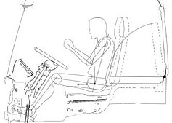

Store case with large room, cup stand, and wide berth
There is wide store space in the vehicle roof. The wide berth will relax the driver easily.

Front top storage box
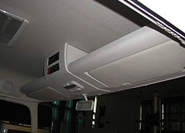
Double cup stand
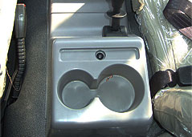
Wide berth
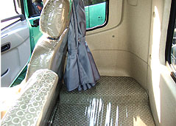

Lighting, air-conditioning, heater and good audio system

In the cab, a very bright reading light is applied to ensure a best lighting effect. The spheroidal air outlet will prevent the side window from frosting or fogging. The automatic air-conditioning may be mounted to keep a comfortable temperature by adjusting automatically.

Reading light
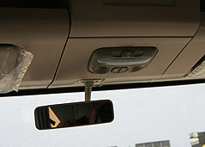
Air conditioning
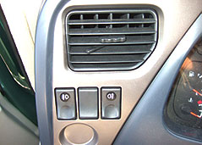

Electric control radio and tape player, with CD/DVD possible to be added any time. The buttons are concentrated on the door side.

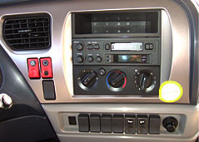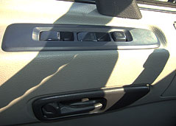

Considerate up/down fender apron and handle give the driver convenience.

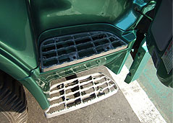
Two-step fender apron
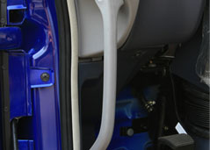
Driver side handle

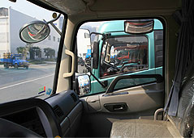
Passenger side door handle, door post handrail
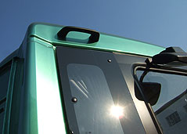
Handrail

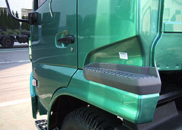
Wheel spad fender apron

Integrated system testing
Mature chassis matching technology has passed the reliability test.
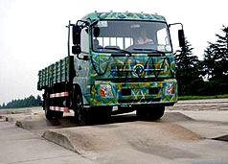
Complex road condition test
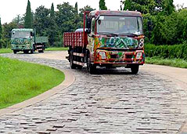
Bumping road condition test
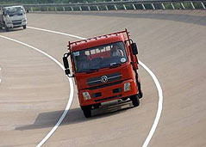
Expressway condition test

Mature and reliable system assembly

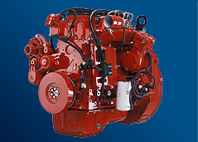
Dongfeng Cummins Engine - the most reliable engine deemed publicly with high reliability and durability.
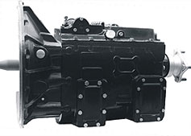
Mature Dongfeng 6-shift gear-box with improved torque and reliable quality.
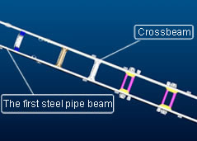
The 250mm high strength steel double-layer crossbeam is firm and durable; the first steel pipe beam has a great torque strength.
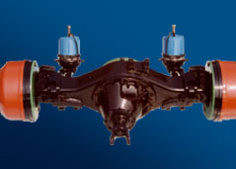
Dongfeng Dana 9-t/10-t rear axle is the most mature and reliable single-reduction axle in China.

